cnc_searchword

声明
/* line edit (search string) */
[DllImport("FWLIB32.dll", EntryPoint="cnc_searchword")]
public static extern short cnc_searchword( ushort FlibHndl,int a, uint b, short c, short d, uint e, [In,MarshalAs(UnmanagedType.AsAny)] Object f );
描述
搜索NC程序中的字符。
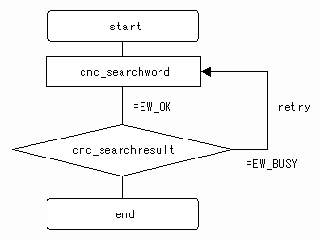

参数
（1）FlibHndl 库句柄；[ in ]

函数返回值
函数运行正常返回EW_OK。
Return code | Meaning/Error handling
EW_BUSY  (-1) | Busy  - except 30i/31i/32i, 0i-D, PMi-A  Some alarm has existed or CNC is searching the program text right now.  - 30i/31i/32i, 0i-D, PMi-A  CNC is searching the program text right now.
EW_DATA  (5) | Data error  In order to get more information for this err_no return value, execute cnc_getdtailerr function.  The following detail status will be set onto the member, err_no of ODBERR structure.
  1 | : | The program number(prog_no) error
  3 | : | The search type(type) error
  4 | : | The search direction(direct) error
  5 | : | The repeat count(repeat) error
  6 | : | The size of string error
  7 | : | The content of the string error
EW_NOOPT  (6) | No option  The extended driver/library function is necessary.
EW_MODE  (12) | CNC mode error
EW_PROT  (7) | Write protection in CNC side  CNC parameter is a state of write-protection(O8000-/O9000- protection, encoding).
EW_REJECT  (13) | CNC execution denied  - except 30i/31i/32i, 0i-D, PMi-A  MDI edit or Background edit processing in CNC side.  - 30i/31i/32i, 0i-D, PMi-A  CNC is in the emergency stop.

代码

